Full Load

Incremental Load

CDC

Schema Drift

* Allow schema drift
  + Keeps track of changes in the number of columns
* Infer drifted column types
  + Keeps track of changes in the data type of the columns

Azure Run Book

* Set of instructions to carry out some executions
* Example: Azure Automation Runbook
* To create an automation account
  + Search for Automation Accounts service
  + Create an automation account

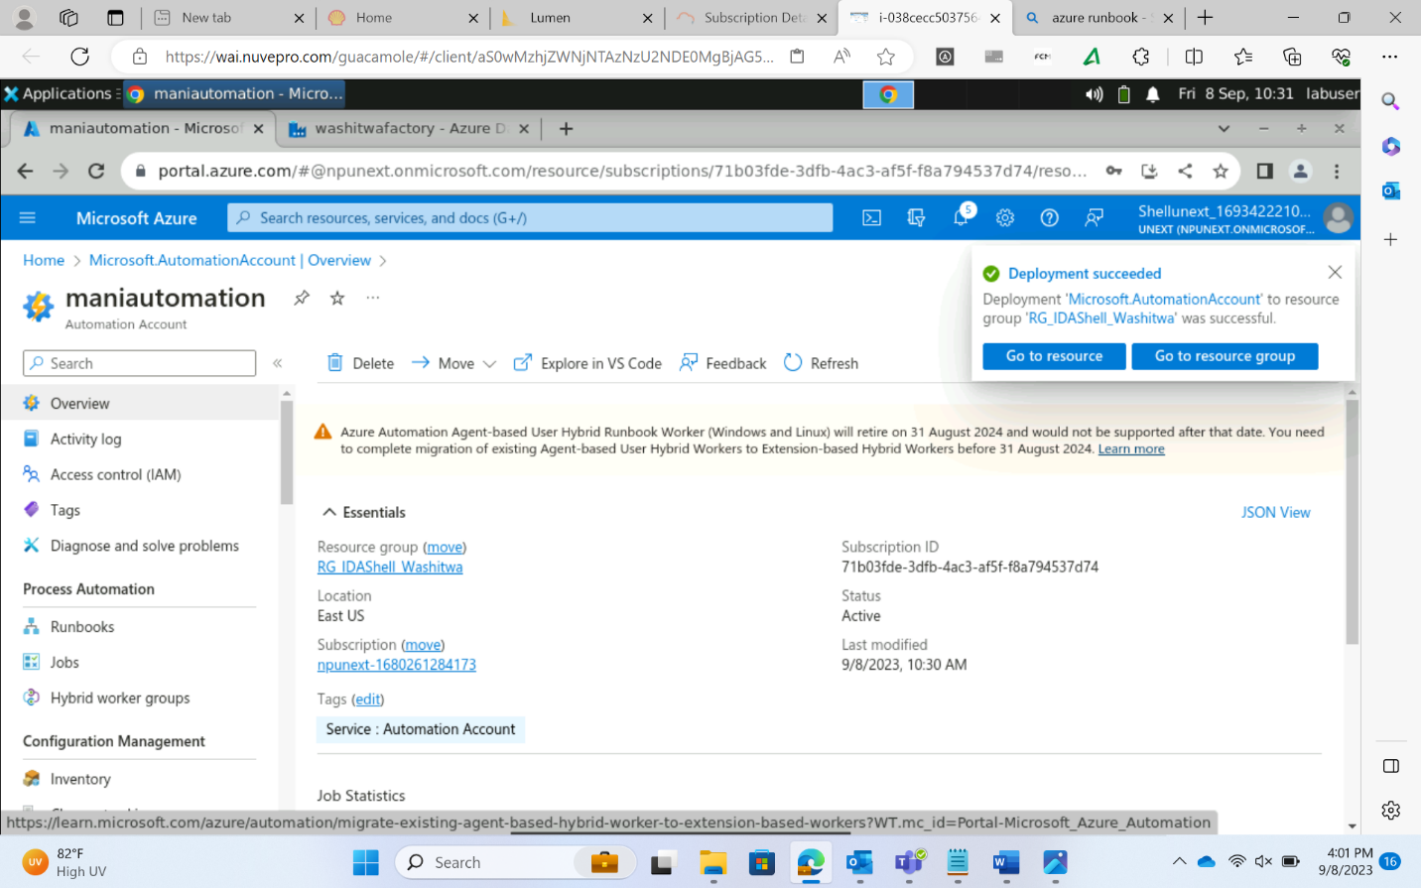

* Multiple scripting shells are present to write the code for automations
* These shells can be
  + PowerShell
  + Graphical PowerShell
  + Unix Shell
* Wherever possible, try to write comments. It is a convention to make the code more readable
* Instead of writing code, drag and drop options available with some shells that allow easier automation
* Multiple services are present inside the automation account to provide specific automation support for different Azure resources
* Creation of a Runbook in Automation account

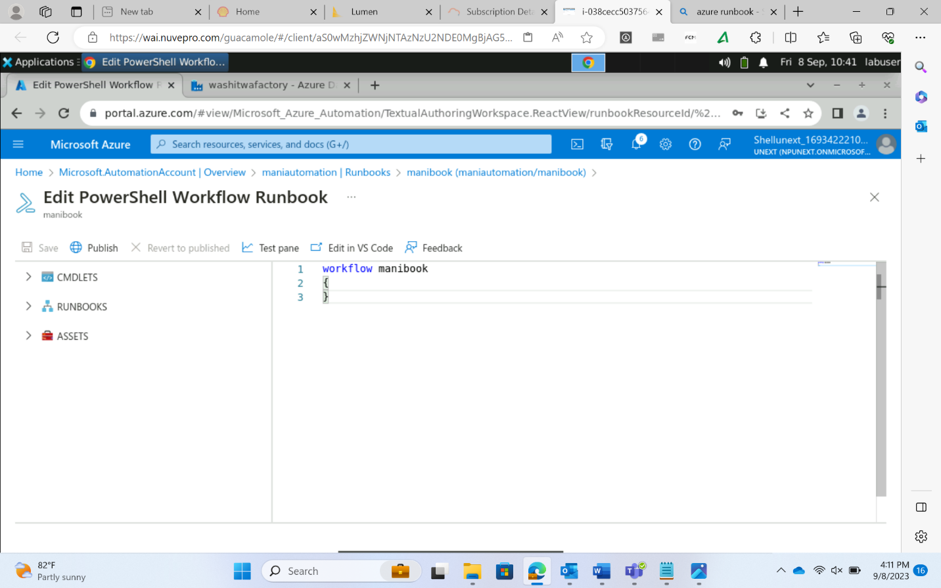

* Difference between sequence and pipeline
  + Pipeline keeps giving continuous outputs whereas pipeline gives outputs only upon completion

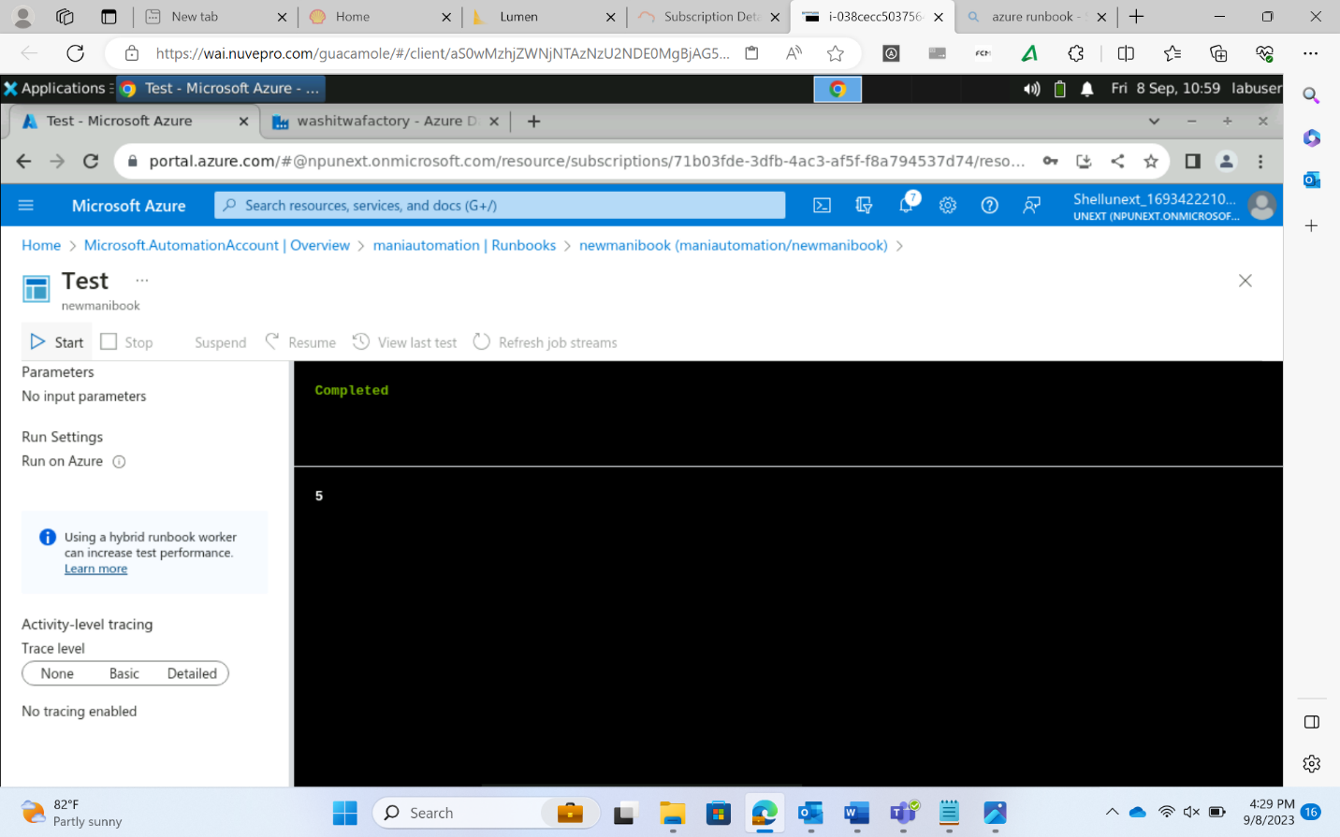

Azure Monitor

* To monitor every other Azure Service
* Monitor -> metrics, select scope, then check the metrics

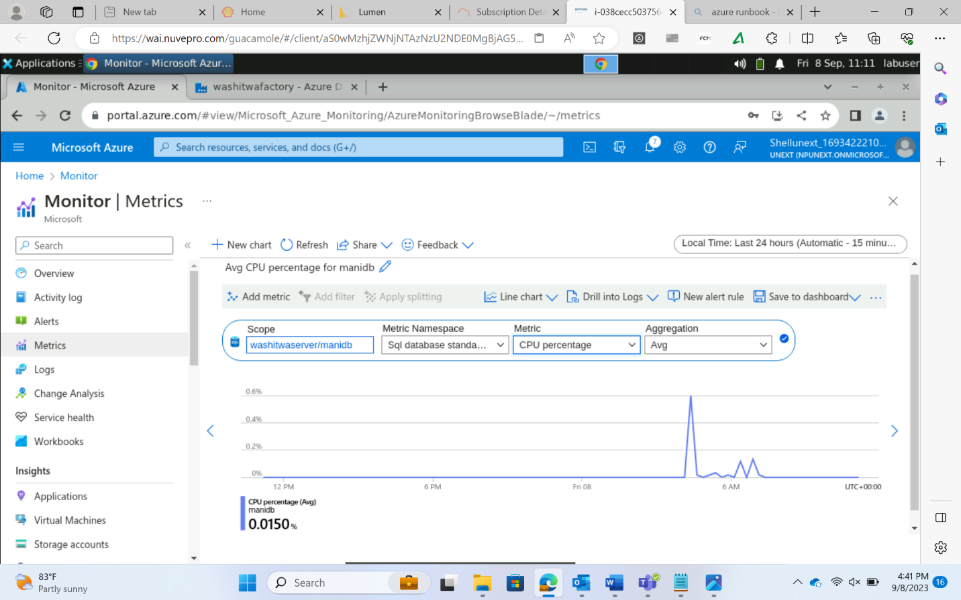

* Alert option can be used in Monitor service to generate alerts when a certain level of resources are utilized